PROTOCOL FOR ADMINISTRATION OF VACCINES BY PHARMACISTS

Table of Contents
PROTOCOL FOR ADMINISTRATION OF VACCINES BY PHARMACISTS 2
I. Introduction 2
II. Authorization 2
III. Qualifications 2
IV. Limitations on Pharmacy‐based Vaccination 3
V. Protocol, Facility and Equipment 3
VI. Informed Consent 3
VII. Pharmacy‐based Vaccination Record 3
VIII. Reporting Requirements 4
IX. Vaccination Safety 4
X. Management of Adverse Events 5
XI. Supply Considerations 5
XII. Vaccines 5
CERTIFICATION 5
APPENDIX A—KANSAS VACCINATION LAWS 7
APPENDIX B—REQUIRED SUPPLIES AND EQUIPMENT 8
APPENDIX C—CDC & KDHE VACCINE INFORMATION 9
APPENDIX D—GENERAL SCREENING QUESTIONNAIRE TO DETERMINE SAFETY OF LIVE VACCINES 10
APPENDIX E—KDHE Vaccine Documentation/Consent Form 11
APPENDIX F—PROCEDURES FOR MANAGEMENT OF ADVERSE REACTIONS TO VACCINES 15
APPENDIX G—Vaccine Adverse Event Reporting System (VAERS) 17

PROTOCOL FOR ADMINISTRATION OF VACCINES BY PHARMACISTS

I. Introduction
To help increase the vaccination rates in Kansas, a licensed pharmacist may administer vaccines according to K.S.A. 65-1635a. Unless a licensed pharmacist is prohibited from administering a vaccine by the U.S. Centers for Disease Control (CDC), the Kansas Department of Health and Environment (KDHE), or the Kansas State Board of Pharmacy (Board), there shall be a written protocol for the administration of vaccines by a pharmacist.

II. Authorization
Subject to the requirements of this Protocol, pharmacists that meet the qualifications specified in Section III below and all applicable law and regulations may:
- Determine vaccination needs in accordance with the current schedule recommended by the CDC’s Advisory Committee on Immunization Practices (ACIP);
- Screen all patients for contraindications and precautions for vaccines needed using screening questions for all vaccines (Appendix E), live vaccines (Appendix D), and vaccine-specific screening as set forth in other Appendices as indicated in this Protocol;
- Administer vaccines according to directions provided in section XII of this Protocol; and
- Administer epinephrine and diphenhydramine in response to acute allergic reactions precipitated by vaccination as delineated in this Protocol.
This Protocol shall be effective on the date signed by the authorizing physician or the pharmacist, whichever is later, and shall expire two years from the date signed by the authorizing physician.

III. Qualifications
A pharmacist or pharmacy intern supervised by a pharmacist seeking authorization to administer vaccines pursuant to this Protocol shall meet the following qualifications:
- Licensure—The pharmacist must be actively licensed and in good standing with the Board. The pharmacy intern must have a valid permit from and be in good standing with the Board.
- Cardiopulmonary Resuscitation (CPR) Certification—The pharmacist and pharmacy intern must, at a minimum, obtain and maintain certification in CPR. A pharmacist may substitute one of the following courses, which are required to be renewed every two years from a national accredited program:
- Basic Life Support (BLS) for healthcare provider course
- Advance Life Support (ACLS) for healthcare provider course
- Training—The pharmacist and pharmacy intern must complete an approved pharmacy‐based Immunization training program that is accredited by the Accreditation Council for Pharmacy Education (ACPE) or the Board. Training must comply with current CDC guidelines and should include study materials, hands‐on training, techniques for administering vaccines, vaccination storage, protocols, injection technique, emergency procedures, and recordkeeping. At the conclusion of any training course, the pharmacist or pharmacy intern should have knowledge in the following content areas:
- Mechanisms of action for vaccines, contraindications, drug interactions, and monitoring. After vaccine administration, in the event of a conflict between information provided in package inserts and ACIP recommended guidelines, pharmacists administering vaccines pursuant to this Protocol should adhere to ACIP guidelines;
- Standards for vaccination practices;
- Basic immunology and vaccine protection;
- Vaccine‐preventable diseases;
- Recommended immunization schedules;
- Vaccine storage management;
- Biohazard waste disposal and sterile technique;
- Physiology and techniques for vaccine administration;
- Pre‐vaccine and post‐vaccine assessment and counseling;
- Vaccine record management;
- Management of adverse events, including identification, appropriate response, emergency procedures, documentation, and reporting; and
- Needle-stick management.
- Continuing Education—The pharmacist and pharmacy interns are encouraged to annually complete at least one hour of Board-approved or ACPE‐approved continuing education related to the administration of vaccines.
- Liability Insurance—The pharmacist must maintain liability insurance that covers the administration of vaccines.

IV. Limitations on Pharmacy‐based Vaccination
- Age—The administration of non‐influenza vaccines pursuant to this Protocol must not be to any persons under the age of twelve (12) years. The administration of influenza vaccines pursuant to this protocol may not be to any persons under the age of six (6) years.
- Delegation—A pharmacist may not delegate the administration of vaccines to any other person.
- Patient Specific Factors—Potential vaccinees with any contraindications and/or complex medical issues including immunosuppression or history of Guillain‐Barré syndrome should be referred to the person’s primary care practitioner.

V. Protocol, Facility and Equipment
Any immunization protocol, pharmacist immunization training certificate, and CPR certification shall be maintained for at least five years and shall be made available to the Board upon request at each location at which a pharmacist administers a vaccine. Pharmacists administering vaccines under this Protocol shall maintain an appropriate area for administering vaccines with the supplies and equipment listed in Appendix B.

VI. Informed Consent
Before receiving the vaccine, the vaccinee (or his or her legal representative) must be given information about the risks and benefits associated with vaccination.
- Consent Form—Any pharmacist administering vaccines pursuant to this Protocol must document the vaccinee or the legal representative's informed consent in writing prior to administration of a vaccine. Either the pharmacist or the pharmacy intern and supervising pharmacist must be identified on the consent form. A sample consent form can be found in Appendix E.
- Vaccine Information Statements —Each vaccinee or legal representative must be provided with a copy of the most current Vaccine Information Statement (VIS) for the vaccine provided. The vaccinee or legal representative must be given the opportunity to read the VIS prior to administration of the vaccine, and the pharmacist must provide answers to any questions raised. Non‐English-speaking persons must receive a copy of the VIS in their native language, if available. The publication date of the VIS and the date it was provided to the vaccinee must be included in the vaccination documentation. https://vaers.hhs.gov/reportevent.html

VII. Pharmacy‐based Vaccination Record
A pharmacist or pharmacy intern supervised by a pharmacist administering a vaccine pursuant to this Protocol must create a vaccination record for each vaccinee and must maintain this record for a period of at least ten (10) years for patients at least 18 years of age and at least thirteen (13) years for patients under 18 years of age. This vaccination record must be securely stored and readily retrievable during the facility’s normal operating hours, and shall include the CDC documentation requirements (https://www.cdc.gov/vaccines/hcp/admin/document-vaccines.html) including the following:
- The name, address, date of birth, gender, and telephone number of the vaccinee;
- A copy of the vaccinee's responses to eligibility questionnaires;
- The name, dose, manufacturer, and lot number of the vaccine administered;
- The date of the administration of the vaccine and the injection site;
- A signed and dated consent form by which the vaccinee acknowledges receipt of the VIS, the publication date of the VIS, and the date the VIS was provided to the vaccinee, as well as the consent to administration of the vaccine;
- A record of any adverse events or complications that arose following vaccination;
- The name and license number of the administering pharmacist or the administering pharmacy intern and supervising pharmacist;
- The name, address, and telephone number of the pharmacy or facility in custody of the vaccination records; and
- The name of the authorizing prescriber under this Protocol.

VIII. Reporting Requirements
- Personal Immunization Record—The pharmacist or pharmacy intern should encourage all vaccinees to carry a personal immunization record card in their wallet. All vaccinees will be given a written immunization record for their personal files in compliance with K.S.A. 65-1635a.
- Medical Home Notification—When a vaccinee receives a vaccine, the pharmacist or pharmacy intern shall report such vaccine to the designated primary care provider. If the vaccinee does not designate a primary care provider, the pharmacist or pharmacy intern shall report such vaccine to the physician authorizing this Protocol.
- Immunization Registry (KsWebIZ)—The pharmacist or pharmacy intern shall report administration of all vaccinations to the Kansas Immunization Registry in compliance with K.S.A. 65-1635a for reporting vaccinations.
- Adverse Event Reporting—The pharmacist or pharmacy intern shall report any clinically significant event that occurs following vaccine administration to the Vaccine Adverse Event Reporting System (VAERS), even if it is unclear whether the event was caused by the vaccine. Clinically significant events include but are not limited to death, hypersensitivity reactions, and those events described in the manufacturer's package insert as contraindications to additional doses of vaccine. https://vaers.hhs.gov/reportevent.html

IX. Vaccination Safety
- Infection Control and Sterile Technique—Pharmacists and pharmacy interns administering vaccines must follow appropriate precautions to minimize risk for spread of disease. Hands must be cleansed with an alcohol‐based waterless antiseptic hand rub or washed with soap and water between each contact. Gloves must be worn if the pharmacist or pharmacy intern administering the vaccine is likely to come into contact with potentially infectious bodily fluids or has open lesions on his/her hands. Needles used for injections must be sterile and disposable to minimize the risk for contamination.
- Prevention of Needle‐stick Injuries—To prevent inadvertent needle‐stick injury or reuse, needles and syringes must be discarded immediately after use in labeled, puncture‐proof containers located in the same room where the vaccine is administered. Needles must not be recapped before being placed in the container. Safety needles or needle‐free injection devices should be used to reduce the risk for injury.
- Hepatitis B Vaccine—The cost of the vaccine is usually covered by the employer. Pharmacists and pharmacy interns who administer vaccines shall receive the Hepatitis B vaccine series unless:
  - the pharmacist or pharmacy intern has previously received the complete Hepatitis B vaccination series;
  - antibody testing has revealed that the pharmacist or pharmacy intern is immune;
  - the vaccine is contraindicated for medical reasons; or
  - the pharmacist or pharmacy intern signs a Hepatitis B Vaccine Declination Statement.
- Occupational Safety and Health Administration (OSHA) Compliance—Pharmacists must comply with OSHA regulations and applicable state law and regulations regarding the storage and disposal of injection supplies and the disposal of, and prevention of exposure to, biological hazards. A table of VAERS reportable events can be found at https://vaers.hhs.gov/docs/vaers_table_of_reportable_events_following_vaccination.pdf.

X. Management of Adverse Events
All vaccines have the potential to cause an adverse reaction. In order to minimize adverse reactions, vaccinees must be carefully screened for precautions and contraindications before the vaccine is administered. Even with careful screening, reactions may occur. These reactions can vary from trivial and inconvenient (e.g. soreness, itching) to severe and life threatening (e.g. anaphylaxis). If reactions occur, the pharmacist or pharmacy intern must be prepared with procedures for reaction management. The procedures for managing adverse reactions are set forth in Appendix F.

XI. Supply Considerations
The supply of vaccines and the timing of distribution is based on CDC guidance and is not guaranteed. If supplies of vaccines are delayed or limited, the pharmacist or pharmacy intern must comply with state and national guidance and directives for the tiered use of vaccines and must cooperate with health officials and local practitioners to ensure that limited supplies of vaccines are targeted to and reserved for those persons at higher risk for disease and disease‐related complications.

XII. Vaccines
Pharmacists or pharmacy interns supervised by a pharmacist may administer U.S. Food and Drug Administration (FDA) authorized or approved formulations of the vaccines listed below, alone or in combination, provided they follow all requirements set forth in this Protocol, assess patient eligibility according to indications, precautions, and contraindications recommended in current guidelines from the ACIP, and adhere to dosing and administration information provided by the package inserts and ACIP recommended guidelines. Pharmacists or pharmacy interns should encourage the patient to complete the vaccination series.
- COVID-19
- Haemophilus Influenzae
- Hepatitis A
- Hepatitis B
- Human Papillomavirus
- Influenza
- Measles, Mumps, Rubella
- Meningococcal (MCV4 and MenB)
- Pneumococcal (PPSV23 and PCV13)
- Tetanus and diphtheria/Tetanus, diphtheria, and pertussis (Td/Tdap)
- Varicella
- Typhoid
- Zoster

CERTIFICATION

PHYSICIAN AUTHORIZATION
Name | Kansas License Number

I hereby authorize the pharmacist below to administer vaccinations in accordance with this protocol.

^{signature} ^{date signed}

PHARMACIST AUTHORIZATION
Name | Kansas License Number

I hereby accept responsibility under the authority of the above-named physician for administration of vaccines under this protocol.

^{signature} ^{date signed}

APPENDIX A—KANSAS VACCINATION LAWS

https://pharmacy.ks.gov/statutes-regs/statutes-regs

65-1626. Definitions.
For purposes of this act:
(www) "Vaccination protocol" means a written protocol, agreed to and signed by a pharmacist and a person licensed to practice medicine and surgery by the state board of healing arts, that establishes procedures and recordkeeping and reporting requirements for administering a vaccine by the pharmacist for a period of time specified therein, not to exceed two years.

65-1635a. Administration of vaccine; education and reporting requirements; delegation of authority prohibited; "pharmacist" defined.
(a) A pharmacist or a pharmacy student or intern who is working under the direct supervision and control of a pharmacist may administer influenza vaccine to a person six years of age or older and may administer vaccine, other than influenza vaccine, to a person 12 years of age or older pursuant to a vaccination protocol if the pharmacist, pharmacy student or intern has successfully completed a course of study and training, approved by the accreditation council for pharmacy or the board, in vaccination storage, protocols, injection technique, emergency procedures and recordkeeping and has taken a course in cardiopulmonary resuscitation (CPR) and has a current CPR certificate when administering vaccine. A pharmacist or pharmacy student or intern who successfully completes such a course of study and training shall maintain proof of completion and, upon request, provide a copy of such proof to the board.
(b) All vaccinees will be given a written immunization record for their personal files. The administering pharmacist or pharmacist supervising an administering pharmacy student or intern shall promptly report a record of the immunization to the vaccinee's primary care provider by mail, electronic facsimile, e-mail or other electronic means. If the vaccinee does not have a primary care provider, then the administering pharmacist or pharmacist supervising an administering pharmacy student or intern shall promptly report a record of the immunization to the person licensed to practice medicine and surgery by the state board of healing arts who has entered into the vaccination protocol with the pharmacist. The immunization will also be reported to appropriate county or state immunization registries, except that if the person vaccinated or, if the person is a minor, the parent or guardian of the minor, objects to the report, the report shall not be made.
(c) A pharmacist, pharmacy student or intern may not delegate to any person the authority granted under this act to administer a vaccine.
(d) As used in this section, "pharmacist" means a pharmacist as defined in K.S.A. 65-1626, and amendments thereto, who has successfully completed a course of study and training, approved by the accreditation council for pharmacy or the board, in vaccination storage, protocols, injection technique, emergency procedures and recordkeeping and has taken a course in cardiopulmonary resuscitation (CPR) and has a current CPR certificate.

65-2886a. Reporting of administration of vaccines by physicians and other authorized individuals.
(a) On and after July 1, 2020, physicians and other persons authorized by law in this state to administer vaccines shall report the administration of a vaccine to a person in this state to the state registry maintained for such purpose by the secretary of health and environment in a manner and form as may be required by the secretary, except that if the person vaccinated or, if the person is a minor, the parent or guardian of the minor, objects to the report, the report shall not be made.
(b) As used in this section, "physician" means a person licensed to practice medicine and surgery.

APPENDIX B—REQUIRED SUPPLIES AND EQUIPMENT

The following items should be available in the area where vaccines are administered:
- A copy of any vaccination protocol, immunization certificates, and CPR certificates, which shall be retained for five years.
- A supply of the most current federal VIS for vaccines being administered, or electronic access to these statements.
- Aqueous epinephrine USP (1:1000), in ampules, vials of solution, or prefilled devices (example EpiPen). The pharmacy should determine how many adult and pediatric prefilled EpiPens need to be stocked depending on the estimated emergency medicine services (EMS) time of arrival at their pharmacy location.
- Diphenhydramine (Benadryl) injectable solution (50 mg per mL) and oral 25 mg dosage form, to include tablets, capsules or liquid.
- Syringes: 1‐mL and 3‐mL, 22g and 25g, 1‐inch, and 1 ½‐inch needles for epinephrine and diphenhydramine.
- Alcohol swabs and bandages.
- Blood pressure monitoring device or stethoscope and sphygmomanometer (with pediatric, adult, and extra‐large cuffs).
- Adult and pediatric size pocket masks with one‐way valve.
- Flashlight with extra batteries (for examination of mouth and throat).
- Timekeeping device with ability to count seconds.
- Telephone access.
- Equipment to enable the vaccinee to sit or lie down if he/she experiences an adverse reaction to the vaccine, such as a mat or a reclining chair.

APPENDIX C—CDC & KDHE VACCINE INFORMATION

CDC Immunization Schedules: https://www.cdc.gov/vaccines/schedules/index.html

Vaccine Information Statements (VIS): https://www.cdc.gov/vaccines/hcp/vis/index.html

CDC Requirements and Laws: https://www.cdc.gov/vaccines/imz-managers/laws/index.html

CDC Common Vaccine Safety Concerns: https://www.cdc.gov/vaccinesafety/concerns/index.html

Multiple Vaccines and the Immune System: https://www.cdc.gov/vaccinesafety/concerns/multiple-vaccines-immunity.html

KDHE Kansas Immunization Information System (KSWebIZ): https://webiz.kdhe.ks.gov/webiznet_ks/login.aspx

APPENDIX D—GENERAL SCREENING QUESTIONNAIRE TO DETERMINE SAFETY OF LIVE VACCINES

Below is a list of screening questions the pharmacist or pharmacy intern must ask a patient prior to administration of a live vaccine (in addition to the standard questionnaire). This is a list of general questions. Vaccine-specific screening questions must also be asked based on the vaccine’s contraindications and precautions according to ACIP guidelines.

- Are you currently on home infusions or weekly injections (such as Remicade, Humira, Enbrel, Cimzia, Simponi, Simponi Aria, Xeljanz, Orencia, Arava, Actermra, Cytoxan, Rituxan, adalimumab, infliximab or etanercept), high‐dose methotrexate, azathioprine or 6‐mercaptopurine, antivirals, anticancer drugs or radiation treatments?
- Have you received any vaccinations or skin tests in the past four weeks?
- Have you received a transfusion of blood, blood products, or been given a medication called immune (gamma) globulin in the past year?
- Are you currently taking high‐dose steroid therapy (prednisone >20mg/day or equivalent) for longer than two weeks?

APPENDIX E—KDHE Vaccine Documentation/Consent Form
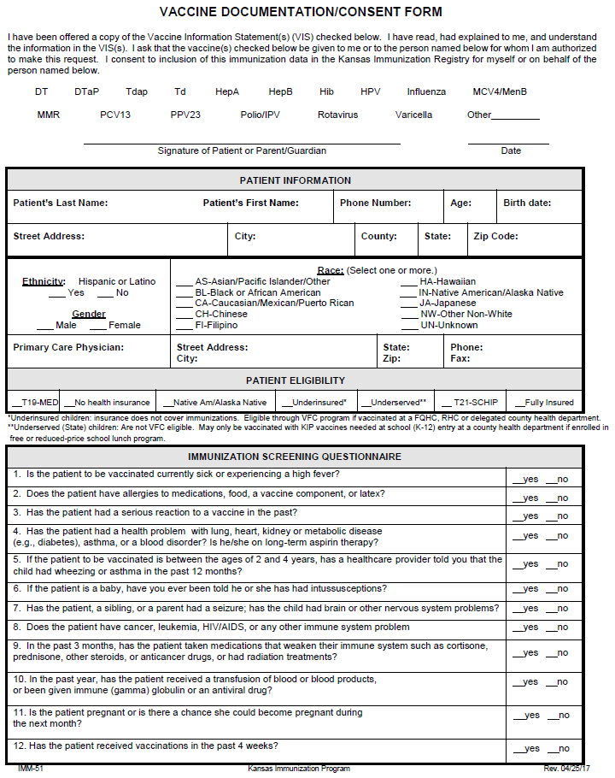
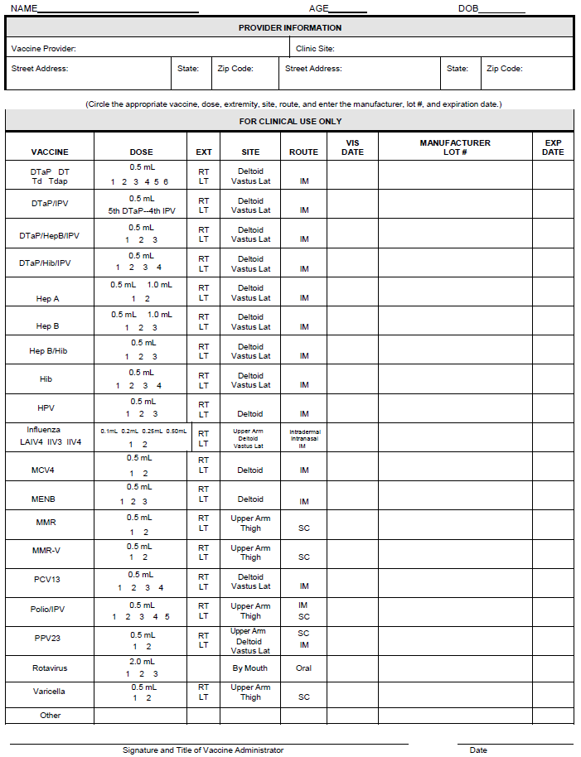
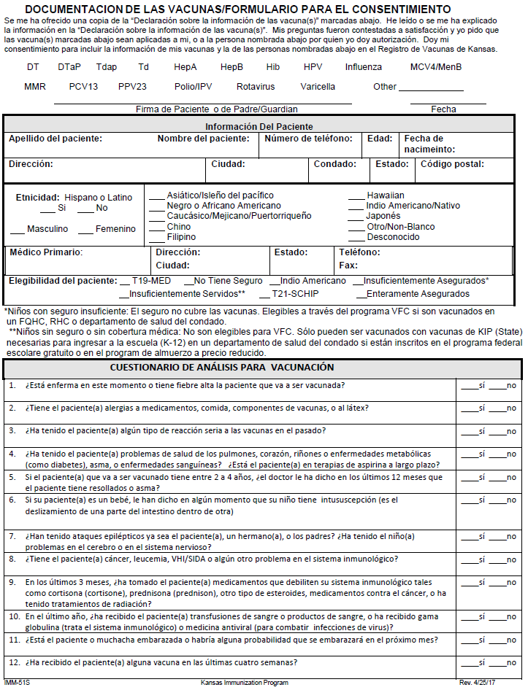
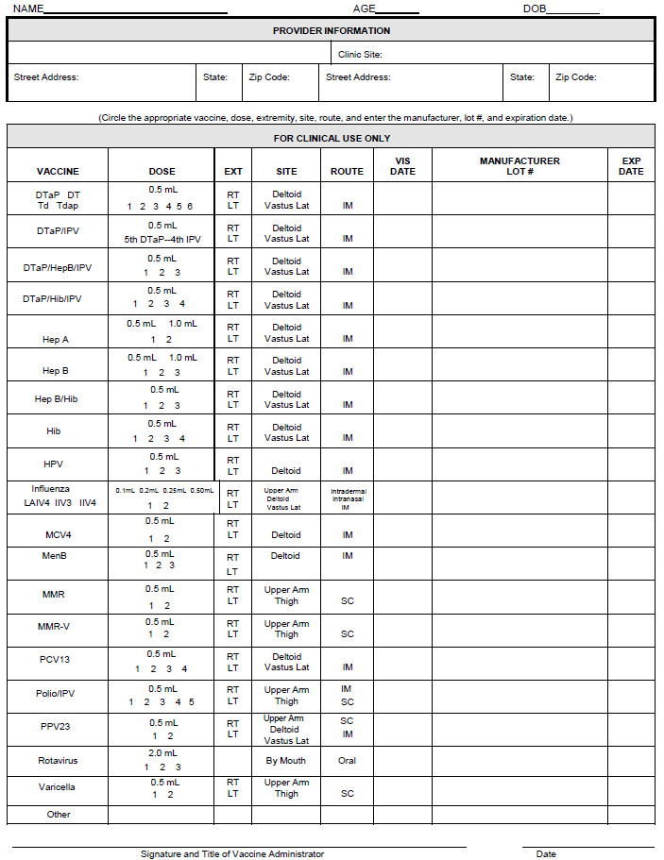

APPENDIX F—PROCEDURES FOR MANAGEMENT OF ADVERSE REACTIONS TO VACCINES

Anaphylactic Reactions
Signs and symptoms of anaphylactic reaction include:
- the sudden or gradual onset of generalized itching, erythema (redness), or urticaria (hives);
- angioedema (swelling of the lips, face, or throat);
- bronchospasm (wheezing);
- shortness of breath;
- shock;
- abdominal cramping; or
- cardiovascular collapse
The following procedures should be used to manage anaphylactic reactions following vaccination:
- If itching and swelling are confined to the injection site where the vaccination was given, observe the vaccinee closely for at least 30 minutes, watching for the development of generalized symptoms.
- If symptoms are generalized, activate the emergency medical system (e.g., call 911) immediately. This should be done by a second person, while the pharmacist assesses the level of consciousness, circulation, airway and breathing of the vaccinee.
- Place vaccinee in a recumbent position and elevate legs.
- The first‐line therapy in anaphylaxis is epinephrine. There are no contraindications to epinephrine in the setting of anaphylaxis.
  - Administer aqueous epinephrine 1:1000 dilution intramuscularly, 0.01mL/kg/dose (adult dose ranges from 0.3mL to 0.5mL, with a maximum single dose of 0.5mL), as indicated:
Ampules or vials of solution:
Weight (lbs) Weight (kg) Epinephrine Dose
- 22‐44 lbs (10‐20 kg) = 0.15mg (or mL) IM X 1 dose
- 45‐88 lbs (21‐40 kg) = 0.30mg (or mL) IM X 1 dose
- 89‐110 lbs (41‐50 kg) = 0.45mg (or mL) IM X 1 dose
- 111 lbs+ (51 kg+) = 0.50mg (or mL) IM X 1 dose
Prefilled devices (i.e., EpiPen Jr. / EpiPen):
Weight (lbs) Weight (kg) Epinephrine Dose
- 33‐66 lbs (15‐30 kg) EpiPen®Jr ‐ 0.15mg IM X 1 dose
- >66 lbs (>30 kg) EpiPen® ‐ 0.30mg IM X 1 dose
The site of injection can be gently massaged to facilitate absorption.
  - If EMS has not arrived and symptoms are still present, the dose of epinephrine may be repeated every 5 to 15 minutes for up to 3 doses, depending on the patient’s response.
- Antihistamines may be given for hives or itching. Administer diphenhydramine either orally or by intramuscular injection. The standard dose is 1‐2 mg/kg every 4‐6 hours, up to 100 mg maximum single dose for adults, and 50 mg maximum single dose for children and adolescents. Do not attempt to give oral medications to a vaccinee who is not fully alert and able to swallow safely. Refer to the dosing chart below:
Age Group Weight (lbs) Weight (kg) Diphenhydramine Dose (Injectable dose based on 50 mg/ml solution)
- 1‐6 months 9‐15 lbs (4‐7 kg) = 5 mg (0.1 mL) IM X 1 dose
- 7‐36 months 16‐31 lbs (8‐14 kg) = 10‐15 mg (0.2‐0.3mL) IM X 1 dose
- 37‐59 months 32‐42 lbs (15‐19 kg) = 20 mg (0.4mL) IM X 1 dose
- 5‐12 yrs. 43‐99 lbs (20‐45 kg) = 30‐40 mg (0.6‐ 0.8mL) IM X 1 dose
- 13 yrs. and older 100+ lbs (46+ kg) = 50‐100 mg (1‐2 mL) IM X 1 dose
- Monitor the vaccinee closely and check vital signs (blood pressure, pulse, and respirations) every 2 to 5 minutes.
- Stay with vaccinee until EMS arrives.
- If necessary, perform cardiopulmonary resuscitation (CPR) and maintain airway.
- Keep vaccinee in supine position unless he or she is having breathing difficulty. If breathing is difficult, vaccinee's head may be elevated, provided blood pressure is adequate to prevent loss of consciousness. If blood pressure is low, elevate legs.
- Record all vital signs, medications administered to the vaccinee (including the time, dosage, response, and the name of the person who administered the medication), and other relevant clinical information contemporaneously in an adverse reaction medication log to be maintained by the pharmacy, a copy of which may be provided to EMS and/or the vaccinee’s primary care provider. A Vaccine Adverse Event Reporting System (VAERS) form is attached as Appendix G.
- Notify the vaccinee's primary care practitioner as soon as possible. All vaccinees experiencing anaphylactic reactions must be referred for evaluation, even if symptoms resolve completely.

References
Immunization Action Coalition. Medical Management of Vaccine Reactions in Adult Patients.
Retrieved from http://www.immunize.org/catg.d/p3082.pdf. January 18, 2021.

Immunization Action Coalition. Medical Management of Vaccine Reactions in Children and Teens. Retrieved from http://www.immunize.org/catg.d/p3082a.pdf. January 18, 2021.

APPENDIX G—Vaccine Adverse Event Reporting System (VAERS)

https://vaers.hhs.gov/

VAERS Background
Online reporting is strongly encouraged. Please report clinically important adverse events that occur after vaccination of adults and children, even if you are not sure whether the vaccine caused the adverse event. The Vaccine Adverse Event Reporting System (VAERS) provides a table of reportable events following vaccination: https://vaers.hhs.gov/docs/vaers_table_of_reportable_events_following_vaccination.pdf.
The VAERS accepts all reports, including reports of vaccination errors. Guidance on reporting vaccination errors is available if you have additional questions. https://vaers.hhs.gov/reportevent.html

Information you will need to complete a VAERS.
- Patient information (age, date of birth, sex)
- Vaccine information (brand name, dosage)
- Date, time, and location administered
- Date and time when adverse event(s) started
- Symptoms and outcome of the adverse event(s)
- Medical tests and laboratory results (if applicable)
- Physician’s contact information (if applicable)

Online VAERS Reporting: https://vaers.hhs.gov/esub/index.jsp
Download VAERS pdf form: https://vaers.hhs.gov/uploadFile/index.jsp

